ATOMIC STRUCTURE WORKSHEET

Complete the table. There is enough information given for each element to determine all missing numbers.

Symbol | Atomic Number | Mass Number | Number of Protons | Number of Electrons | Number of Neutrons
²³Na
K |  | 40 |  | 19
 |  |  | 38 | 38 | 52
F |  |  |  |  | 10
 | 20 | 41 |  | 18
 | 50 |  |  | 50 | 72
¹³¹I
²⁶Mg
 |  | 109 | 47 | 46
 | 1 | 2 |  | 1
³⁶S
 | 26 |  |  | 23 | 32
²⁷Al
 | 2 | 4 |  | 2
Cr |  | 53

Atomic Definitions

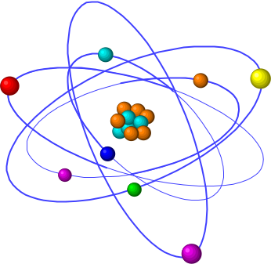

Complete the definitions below about atoms.

- Matter is anything that has and takes up .

- An Atom is the smallest unit of .

- Protons are the sub-atomic particles that are - charged and situated in the nucleus of the atom.

- Neutrons are the sub-atomic particles that are - charged and situated in the nucleus of the atom.

- Electrons are

- The Atomic Number is the number of

- The Mass Number is the total number of

- An Ion is a charged that has either lost or gained negatively- charged

- A Negative Ion is a charged atom that has electrons.

10. A Positive Ion is a charged atom that has electrons.

11. An Element is a pure substance that is made of only type of atom (e.g. gold, oxygen).

